**İSTANBUL MEDİPOL UNIVERSITY**



**EECD1212913: DIGITAL COMMUNICATION LABORATORY**

**Lab report No:.2: Understanding Test Equipment**

**Professor: Huseyin Arslan**

**Student Name: Salim Mohd Yahya**

**Student Number:**  **D3230014**

**Submitted: 13th March 2024**

**Introduction**

The objective of this lab is to familiarize ourselves with the test equipment starting with the generation of communication signals, measurement of the signals and corresponding analysis using lab equipment such as VSA, VSG. Understanding how to use various visual inspection plots such as polar, constellation, eye diagrams, Cumulative Distribution Functions among many others. The lab also provides insight into using MATLAB for controlling the Software Defined Radios to generate and receive communication signals.

1. ***SPECTRUM ANALYSIS***
2. ***Wired vs Wireless Connections***

Object Initialization Settings for transmitter and receiver.

Table 1 Tx and RX Initialization Settings

|  |  |  |  |
| --- | --- | --- | --- |
| **SN** | **Parameter** | **Transmitter** | **Receiver** |
| 1 | Gain: | -20dB | 0dB |
| 2 | CenterFrequency: | 2.4GHz | 2.4GHz |
| 3 | BasebandSampleRate: | ${10}^{6}$ Samples/s | ${10}^{6}$ Samples/s |
| 4 | RadioID: *(found using findPlutoRadio command)* | sn:10447354119600060d001800cf281e583b | sn:104473dc599300131200210082672a4170 |
| 5 | Samples per frame |  | ${40x10}^{3}$ Samples |
| 6 | GainSource |  | Manual |
| 7 | OutputDataType |  | Double |

6. The peak power obtained during wired connection is higher than the one obtained during wireless connection, this can be attributed to lower losses with wired connection as compared to wireless, the discrepancy can be attributed to pathloss in wireless whereas for the coaxial cable relatively lower losses are experienced due to wire resistance.

In wireless transmission side lobes have higher power as compared to those of wired transmission

|  |  |
| --- | --- |
|  |  |
| Wired Transmission | Wireless Transmission |

1. ***Occupied Bandwidth***

Modulation and Filter Set ups applied.

|  |  |  |  |
| --- | --- | --- | --- |
| **SN** | 1. ***Modulation Set Up*** | | |
|  | **Parameter** | **Value** | |
| 1 | Type (T): | QAM | |
| 2 | Order (M): | 4 | |
| 3 | Number of symbols (N): | 500 symbols | |
|  | 1. ***Filter Set Up*** | | |
|  | **Parameter** | **Value** | |
| 1 | Type (T): | Raised cosine (RC) | |
| 2 | Oversampling ratio (sps): | 8 samples | |
| 3 | Span (span): | 12 symbols | |
| 4 | Roll-off (alpha): | 0.5 | |
|  | 1. ***Receiver Set up*** | | |
| 1 | GainSource | | AGC Fast Attack |

**Question 3**

The figure shows power spectrum of the signal in time domain, it can be observed that most of the signal occupies an average power of around -5dB, with some peaks and many fades



**Question 4**

Unlike in A.I where peak power exists only at a particular frequency, which suggests that in A.I no sampling and filter shaping was done and hence did not transmit samples, in this case, after we applied modulation and filtering, the frequency band was populated with samples as the figures depict, both the power and the occupied frequency bandwidths are affected. Lower power is received when modulations and filtering are used as compared to part A.I due to susceptibility to attenuations.

|  |  |
| --- | --- |
|  |  |

**Question 5**

The 99% bandwidth shows that the power (energy) of 99% of our received symbols lies within that bandwidth which is 139.73kHz in our case, this is a helpful measure in spectrum management to ensure that our transmitted signals do not leak to other frequencies apart from the central frequency. 50% OBW tells us how much bandwidth has taken 50% of the energy of our received symbols. We obtain this by taking the energy carried by symbols occupying a particular frequency to the total energy occupied by the signal.

The OBW can also show us the intended central frequency vs the actual transmission frequency by looking at the symmetry of the plot, and whether it’s shifted to left or right of 0 Khz Mark

|  |  |
| --- | --- |
|  |  |

1. ***DIGITAL DEMODULATION ANALYSIS***

***Question 1. The constellation diagrams of returned symbols are as shown in figure.***

***Question 2: The modulations and corresponding orders were changed as in table***

Table 2 Settings for Plotting PSK and QAM 16 Order Modulations

|  |  |  |
| --- | --- | --- |
| **S.N** | **Parameter** | **Value** |
| **1** | Modulation type (T) | PSK, QAM |
| **2** | Order | 16 |

|  |  |
| --- | --- |
|  |  |
| 1. QAM Modulation, Order 16 | 1. PSK Modulation, Order 16 |

**Question 3** Two signals were sent, one was BPSK (Order 2) and the other 4-QAM (order 4), the eye diagrams for the two signals are as shown in figure the following can be deduced from the plots.

1. With BPSK we receive un-transmitted imaginary parts which can be attributed to noise, QAM is also affected by the noise.
2. From the height of the eye diagram, the signal can be seen to be affected by noise and optimum sampling point is susceptible to errors since there is no significant single point for sampling. This leads to Inter Symbol Interference (ISI)
3. The widths of the eyes suggest jitter problems in the signal which again causes sample timing errors. Increasing the roll off factor can increase the width of the eye.
4. The horizontal lines in the middle denote zero crossings, which suggest high dynamic ranges.

|  |  |
| --- | --- |
|  |  |
| **BPSK received** | **QAM received** |

This can be compared to the eye diagrams of transmitted symbols, the optimum sampling points are clear, as for the width of the eye, although we expect single crossing points between the waves, the multiple crossing points can be attributed to impairments of the transmitting adalm plutos.

|  |  |
| --- | --- |
|  |  |
| **BPSK transmitted** | **QPSK transmitted** |

The constellation diagrams correspondingly shows how the received symbols are distorted from the ideal constellation points, as seen in the eye diagram, the symbols can still be correctly mapped to their corresponding ideal constellation points

|  |
| --- |
|  |

**Question 4**

1. The plots for the polar diagrams

|  |  |
| --- | --- |
|  |  |
| Polar diagram with Alpha = 0.3 | Polar Diagram with Alpha = 0.7 |

With 0.3 alpha, plots show high changes in magnitudes between constellation points which means ***high dynamic range*** compared to alpha 0.7, For 0.7 roll off factor both the I and Q components are contained between magnitude of 0.3 and -03 while for 0.3 alpha the I and Q components span magnitude of more than 0.45 on either side of 0.

1. Spectrum of the received signal is as plotted in figure, the occupied spectrum is higher in alpha 0.7 (150.33 kHz) as compared to 0.3 (128.80kHz), the formula $B = (1+ α)R$ where R is sample rate, so with increasing alpha, we theoretically expect increased occupied bandwidth.

|  |  |
| --- | --- |
|  |  |
| Power Spectrum for alpha = 0.7 | Power Spectrum for alpha = 0.3 |

**Question 5**

Bykeeping the transmitter and receiver at the same distance, we set the following set ups and then transmit the signal.

|  |  |  |
| --- | --- | --- |
| **S.N** | **Parameter** | **Value** |
| **1** | GainSource | Manual |
| **2** | Gain | -10dB, -20dB |

* It can be observed that the EVM increases with time for -20 dB whereas it stays fairly within the same range for -10 dB, the increase of EVM with time can be attributed to clock error in synchronization which becomes more apparent with low transmit power of -20 dB.
* The constellation for -10 dB shows less effect from noise as compared to that of -20dB,
* The constellation points for -20db appear to have been rotated, which suggests time shift that translates to phase shift and hence the clock error.

|  |  |
| --- | --- |
|  |  |

|  |  |
| --- | --- |
|  |  |

**Question 6**

From the CCDF curves we can observe that the 16QAM has more symbols with higher power than the average, which means higher PAPR compared to 4QAM, that is, it is highly likely to find symbols with higher power than the average in 16QAM compared to 4QAM, this can lead to poor performance with amplifiers, suggest presence of sidelobes and higher bandwidth occupation than 4QAM. It can also be said that 16QAM has higher dynamic range than 4QAM

|  |  |
| --- | --- |
|  |  |

1. ***WiFi SPECTRUM ANALYSIS***
2. Using vector analysis mode, the VSA central frequency was set to 2.45 Ghz as seen in the figure

Having tuned the receiver to wifi frequency of 2.45 GHz, sparse signal reception can be seen as per the green lines.

1. The spectrum of the signal captured by VSA is as seen in figure below

This shows spectrum occupancy when a Bluetooth device is opened since it uses frequencies close to the Wi-Fi frequencies, the hopping nature of Bluetooth can be observed

The intensified signal strength indicated by the red lines on the right depict increased spectrum occupation when a Wi-Fi using device is used to access bandwidth demanding services (in this case YouTube) the clumped clusters are because of buffering.

1. ***DATA-SET-BASED QUESTIONS***

**Question 1**. Using pspectrum( ) function, the *‘wave’* signal from ***sig_hops.mat*** was observed over time, as can be seen in figue, the number of hops is two (2), the first hope has peak power of – 16.042dB occurring at the frequency of $0.0788767 x π$ radians/sample, the second has peak power of -14.5918 dB occurring at the frequency of $0.279609 x π$ radians/sample.



**Question 2**. The two sequences ***Set1Sg1.mat*** and ***Set1Sig2.mat*** were loaded and observed with sampling frequency of ***102.4ksps***. Using pwelch(), spectrums for each signal were plotted and their bandwidths were observed, figure shows the plots

|  |  |
| --- | --- |
|  |  |

As can be observed the SetSignal2 plot shows quicker decay of signal power on the sidelobes (***sidelobe suppression***) as compared to setsignal1, the bandwidth of signal2 is higher than that of signal1, both features suggest that signal2 has ***higher roll off factor*** which reduces the sidelobes at the cost of extra bandwidth.

Q3. The three sequences of the samples representing three signals stored in the files SetSig1, SetSig2 and SetSig3 were loaded, and respective plots were plotted, the following are the observations *(for easy reference we will refer to set2sig1 as signal 1, set2sig2 as signal 2 and set2sig3 as signal 3)*

1. For the envelope, absolute values were used to plot, as depicted by the plots, taking approximate values, Signal 3 has higher dynamic range with values as high as above 0.74, followed by Signal 1 which has values as high as above 0.67, the signal with least dynamic range is Signal 2 with values as high as above 0.5.



1. Polar diagrams for each signal were plotted as observed in figure, signal 3 being a 16 QAM, is not as easily observable, however, transitions between far symbols exist such as those denoted by T1 and T2 which lead to higher dynamic ranges. As for signal 1, it has many transitions through the middle which suggest higher dynamic ranges compared to signal 2 which has shorter transitions and none going through the middle.



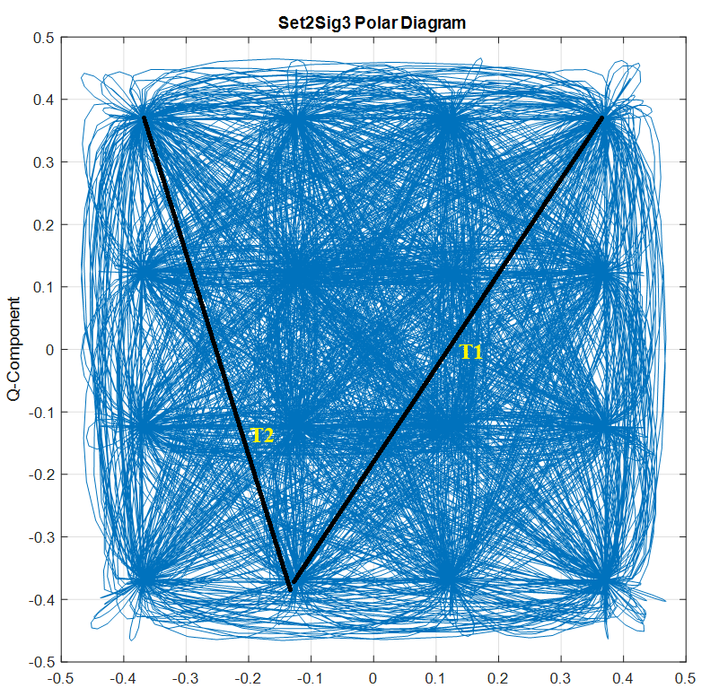

1. Based on CCDF plots, we can also deduce that signal 3 has highest dynamic range followed by signal 2 and then signal 1



1. Figure shows eye diagrams for signal 1 (left) signal 2(middle) and signal 3 (right), it can be concluded that signal 3 has highest modulation order of all three by counting the number of eyes which is 3, which means a modulation order of 16 (16-QAM) is used. *Signal 1* and 2 suggest that QPSK was used. All three signals appear to have used Nyquist filters since the sampling points are very clear (not distorted)

